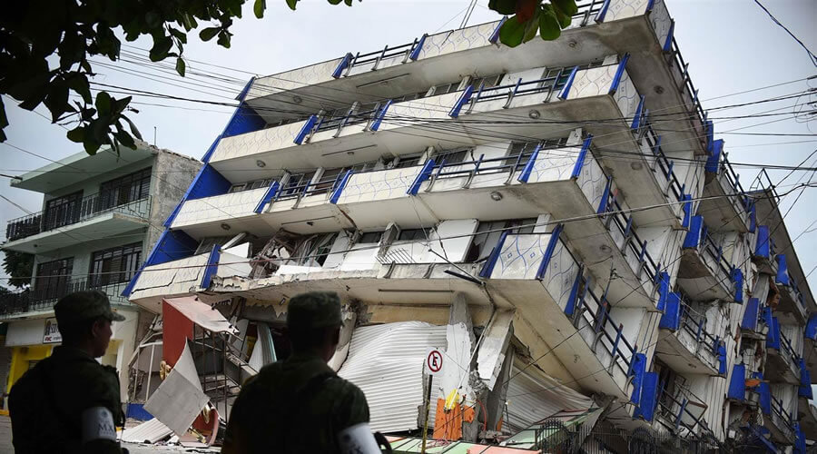
Designing aseismic buildings

Engineering buildings to withstand earthquakes is extremely important in earthquake-prone areas. Before doing this activity, you should research how buildings in MEDC and LEDC countries can be designed and retrofitted to be resistant to earthquakes.
There is a lot of information on the internet about how to make buildings more resistant to earthquakes.
Here’s some videos/websites that can get you started:

https://www.youtube.com/watch?v=c4fKBGsllZI
https://www.youtube.com/watch?v=Bg4kSIgn67I
https://www.bigrentz.com/blog/earthquake-proof-buildings
https://www.digitaltrends.com/cool-tech/earthquake-resistant-buildings/

TASK 1: BUILDING DESIGN PLAN
You are part of a construction company that has been given the task of designing an earthquake resistant skyscraper. Draw or write about your aseismic designed building. The more information and detail, the better.
Things to include:

- The location:(Your building must be built in an MEDC where the risk of earthquakes is high!)
- Building features: - Lower/middle and higher sections of your building. How will each section of your building be designed to resist collapse in an earthquake?
- Earthquake procedures: What information would people be given so that they knew what to do in an earthquake?
- Other design features to increase earthquake resistance

THINGS TO THINK ABOUT:
•Your building will be built in an MEDC country–how will this affect your materials and budget?
•Could you incorporate cross bracing, counter-weights or shock absorbers?
•What is the geology and landscape like? Will this affect your building?
•How would people evacuate safely?
•How would communications, gas and water pipes be protected?

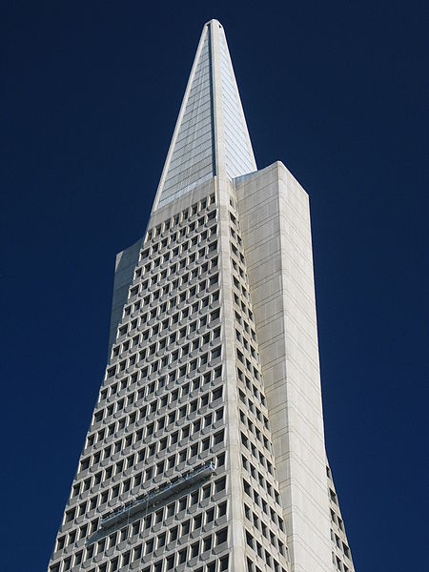
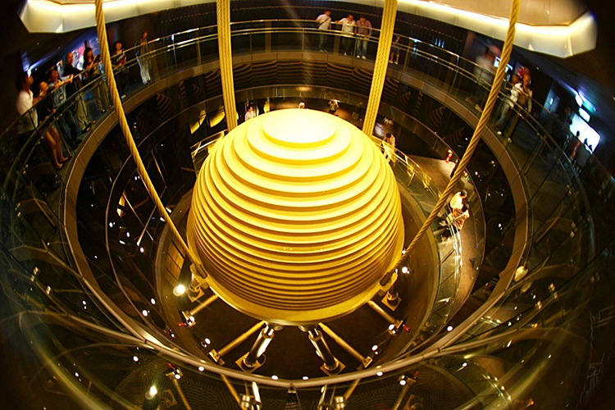
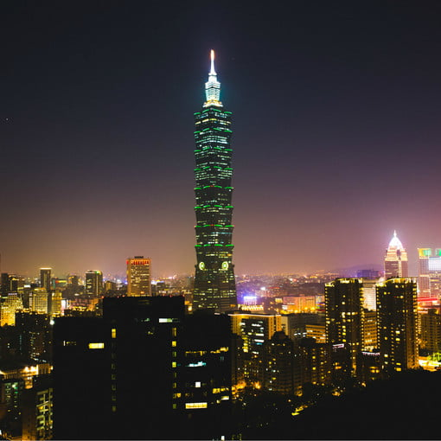
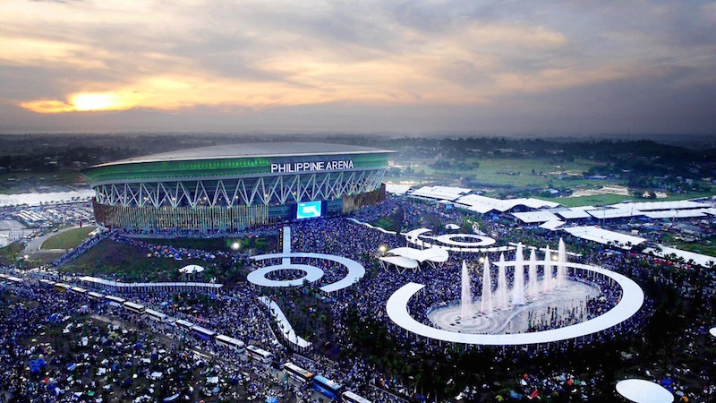
Examples of aseismic buildings:

The Transamerica Pyramid (San Francisco, California)

Philippine arena

Taipei 101, Taiwan.

Others include:

Shanghai Tower (Shanghai, China)

Mori Tower (Tokyo, Japan)

New Wilshire Grand Center (Los Angeles, California)

Sabiha Gökçen Airport (Istanbul, Turkey)

Komatsu Seiren (Nomi, Japan)

